SIKSHA 'O' ANUSANDHAN

## (DEEMED TO BE UNIVERSITY)



**Department of Electronics & Communication Engineering, Institute of Technical Education and Research**



**CIRCUIT THEORY**

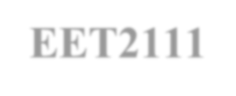

**(EET2111)**



**DESIGN PROJECT**

|  |  |
| --- | --- |
| **SUBMITTED BY** | |
| NAME: | **Anirban Chatterjee** |
| REGISTRATION NO.: | **2241003014** |
| BRANCH – SECTION: | **ECE-35** |
| SEMESTER: | **4th Semester** |

## DECLARATION

I certify that

1. The work contained in this report is original and has been done by me.
2. I have followed the guidelines provided by the Institute in preparing the report.
3. I have conformed to the norms and guidelines given in the Ethical Code of Conduct of the Institute.
4. I have tried to complete the work with minimum possible cost.
5. Whenever I have used materials (data, theoretical analysis, figures, and text) from other sources, I have given due credit to them by citing them in the text of the report and giving their details in the references.

**Submitted By:**

**Name:**

Anirban Chatterjee

**Regd No:**

2241003014

**Branch:**

ECE

**Section:**

2241035

**Signature**

# PROBLEM STATEMENT

Design a 2nd order active Band Stop Filter (BSF) which will stop the signals of frequency range from 1KHz to 5KHz.

# CIRCUIT OPERATING CONSTRAINTS

The design of a 2nd order active Band Stop Filter (BSF) to stop signals within the frequency range of 1KHz to 5KHz involves considering several circuit operating constraints.

The Active Band Stop Filter (BSF) stop the signals within the frequency range of 1KHz to 5Khz.One of the primary constraints is the selection of appropriate operational amplifier (op-amp) circuits. The chosen op-amp should possess characteristics such as high gain, low input and output impedance, and sufficient bandwidth to handle the desired frequency range. Also, the op-amp must be able to operate within the specified power supply voltage limits. Here, we have used 741 IC.

The selection of suitable passive components, including resistors and capacitors, that determine the filter's cut-off frequencies and attenuation characteristics. These components must have values within the range that satisfies the desired frequency range while considering the tolerance and availability of commercially available values. Practically, we have used resistor of 13Kohm for LPF and 5Kohm for HPF.

The selection of the physical implementation, such as board space, component size, and cost, should be taken into account. Practical considerations and limitations in terms of available resources and manufacturing constraints should be considered during the design process.

# THEORETICAL BACKGROUND.

## INTRODUCTION

The band stop filter is formed by the combination of low pass and high pass filters with a parallel connection instead of cascading connection. The name itself indicates that it will stop a particular band of frequencies. Since it eliminates frequencies, it is also called as band elimination filter or band reject filter or notch filter.

1. **OPAMP**

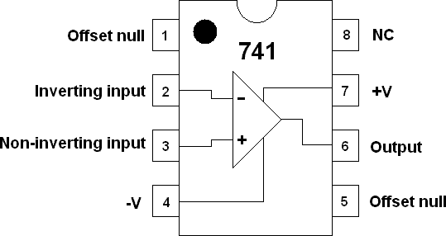

The 741 Op Amp IC is a monolithic integrated circuit, comprising of a general-purpose Operational Amplifier. The number 741 indicates that this operational amplifier IC has 7 functional pins, 4 pins capable of taking input and 1 output pin.

1. **RESISTOR**

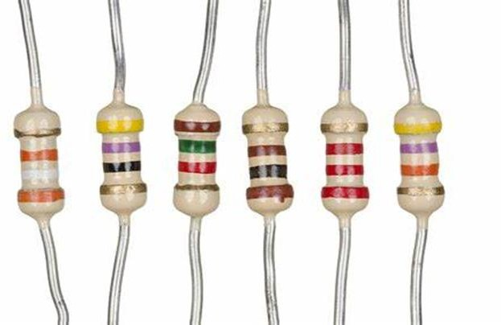

A resistor is a passive two-terminal electrical component that implements electrical resistance as a circuit element. In electronic circuits, resistors are used to reduce current flow, adjust signal levels, to divide voltages, bias active elements, and terminate transmission lines, among other uses. High- power resistors that can dissipate many watts of electrical power as heat may be used as part of motor controls, in power distribution systems, or as test loads for generators.

1. **CAPACITORS**

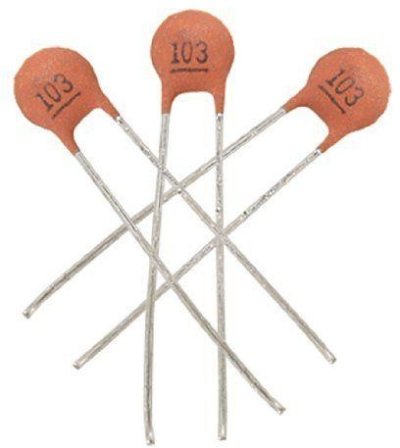

A capacitor is a device that stores electrical energy in an electric field by virtue of accumulating electric charges on two close surfaces insulated from each other. It is a passive electronic component with two terminals. The effect of a capacitor is known as capacitance. While some capacitance exists between any two electrical conductors in proximity in a circuit, a capacitor is a component designed to add capacitance to a circuit.

1. **BLOCK DIAGRAM**

LOW PASS FILTER

# ViV

SUMMING AMPLIFIER **Vo**

HIGH PASS FILTER

1. **MATHEMATICAL MODELLING / ANALYSIS**

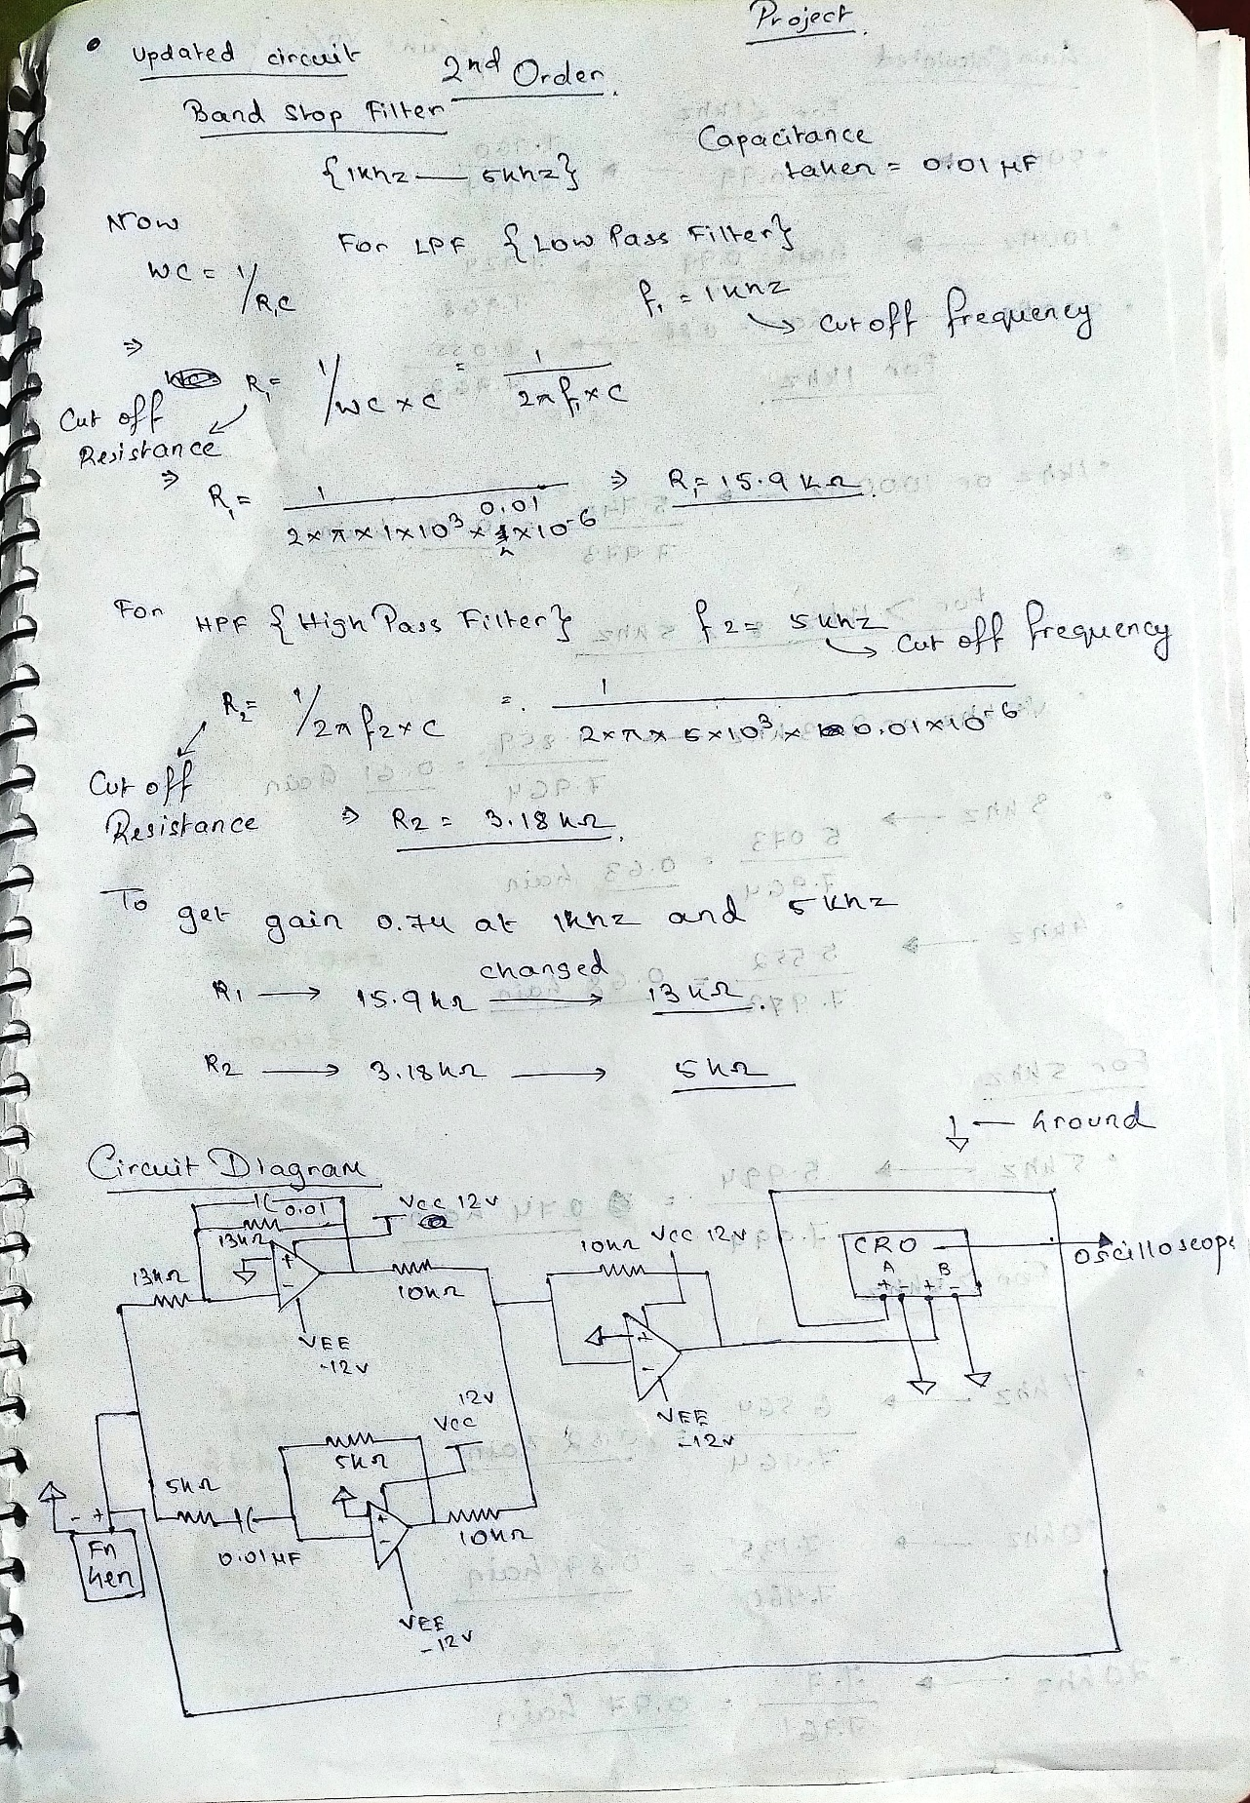

1. **WORKING**

The low pass filter allows the frequencies below its cut-off frequency while the high pass filter allows the frequency above its cut-off frequency. These two cut-off frequencies are predetermined based on the component values used in the circuit. The band stop filter doesn’t allow the frequencies between these two cut-off frequencies and are attenuated or rejected. It has a stopband and one passband. The final output from the high pass filter and low pass filter is amplified by using an operational amplifier (op-amp) to improve the voltage gain.

## Characteristics of Band Stop Filter

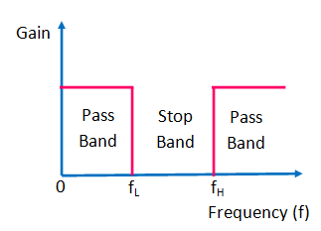

This filter allows the frequencies of a signal in a particular range i.e., above and below the cut-off frequency. So, it has two passbands and one stopband. The stopband represents the attenuated frequencies, ranges between the two cut-off frequencies. While the two passbands the frequencies below and above the cut-off frequencies of low pass and high pass filter circuits.

The main characteristic of the band stop filter is, it allows all the frequencies from zero to up to cut-off frequency and allows all the frequencies above the cut-off frequency. This type of filter the frequencies between the upper and lower cut-off frequencies

## Frequency Response of Band Stop Filter

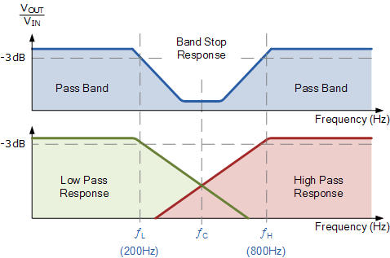

The frequency response is drawn between frequency vs gain.

In practice, the switching mechanism of the capacitor changes the output characteristics of high pass and low pass filters and are not similar to the ideal filter. The passband gain of this filter should be equal to the gain of the low pass and high pass.

## CIRCUIT DESIGN

The design of an active band-stop filter using high-pass and low-pass filters with an operational amplifier (op-amp) can be divided into several blocks or stages, each with its specific function. Here's an overview of the different blocks involved:

1. **High-Pass Filter**: This block is designed to attenuate or block frequencies below the center frequency (f0) of the band stop filter. It typically consists of passive components (such as resistors and capacitors) or active components (such as op-amps) arranged in a configuration that allows higher frequencies to pass through while attenuating lower frequencies.
2. **Low-Pass Filter**: This block is designed to attenuate or block frequencies above the center frequency (f0) of the band stop filter. Similar to the high- pass filter, it can be implemented using passive components or active components in a configuration that allows lower frequencies to pass through while attenuating higher frequencies.
3. **Operational Amplifier (Op-Amp):** The op-amp is used as an active element in the design, serving as a voltage amplifier

and providing gain to the filtered signal. It is typically used to combine the outputs of the high-pass and low-pass filters and provide the final output of the band-stop filter. The op-amp may also require additional passive components, such as resistors and capacitors, to set its gain, bandwidth, and stability.

# CIRCUIT DIAGRAM



1. **DESIGN SPECIFICATION**

|  |  |  |  |  |
| --- | --- | --- | --- | --- |
| **Serial Number** | **Component**  **Name** | **Specification** | **No. of**  **units** | **Price**  **Per**  **Unit** |
| 1. | OPAMP | µA741 | 3 | ₹ 20 |
| 5. | Resistor | 10K, 1K | 7,6 | ₹ 2 |
| 6. | Capacitor | 0.01uF/ 10nF | 2 | ₹ 5 |
| 7. | Connecting Wires | 23SWG | As per  requirement | ₹40 |
| 8. | TOTAL |  |  | ₹136 |

# HARDWARE SETUP

1. **Breadboard Implementation**

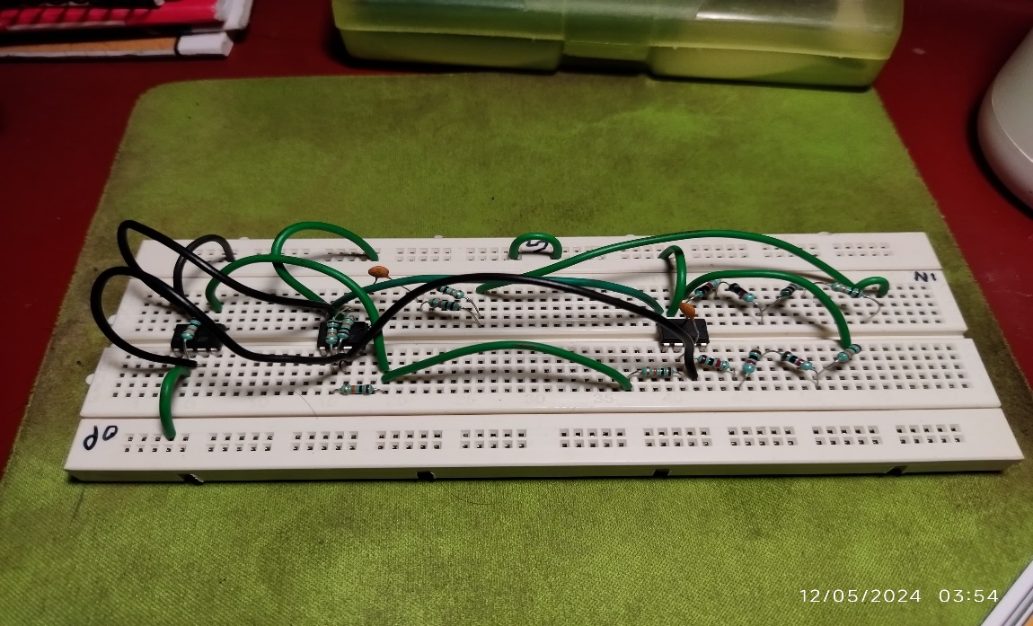

1. **Complete Setup**

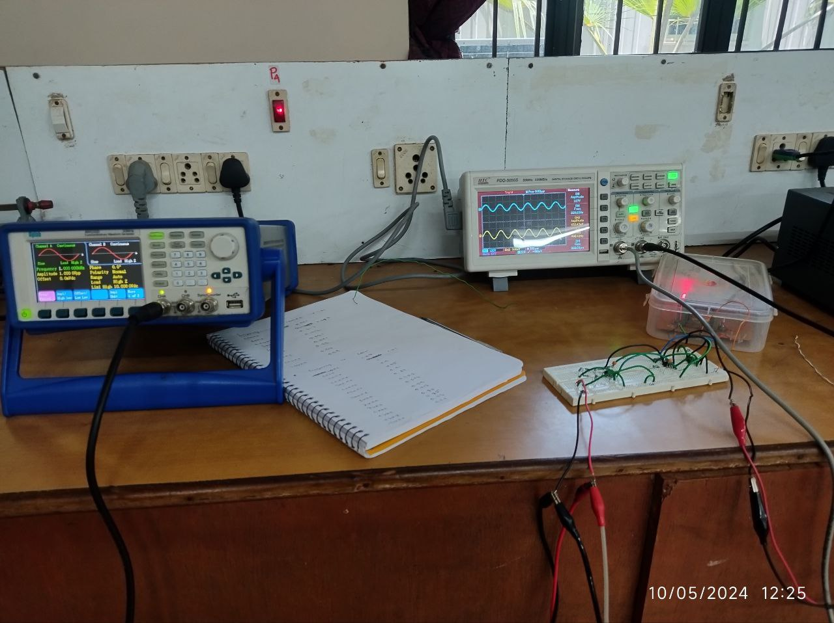

# RESULT

**SIMULATION RESULT**

* 1. Before 1Khz (100 hz , 500 hz)

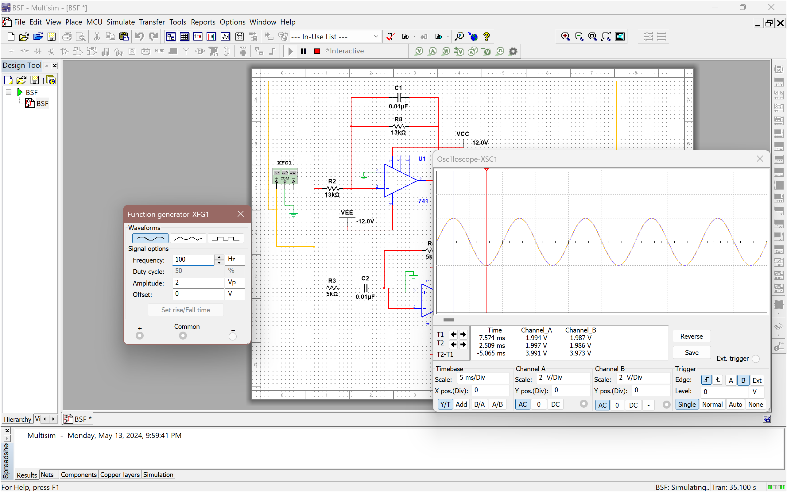

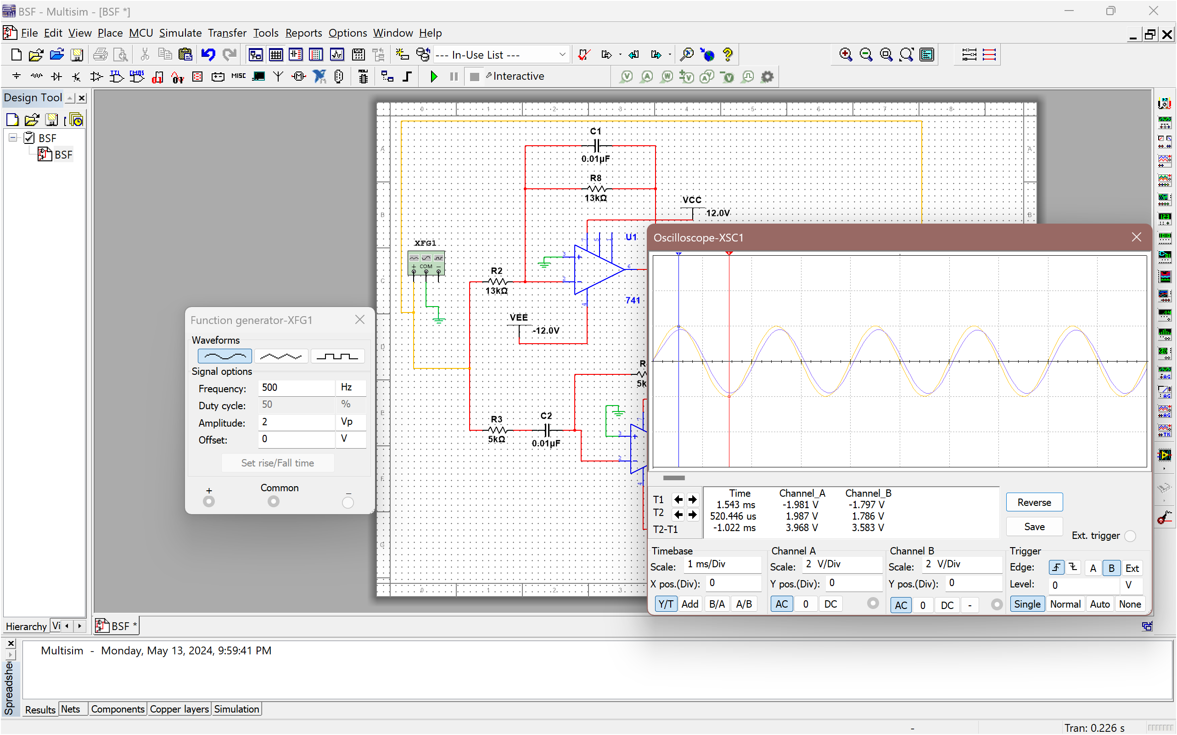

* 1. At 1 khz

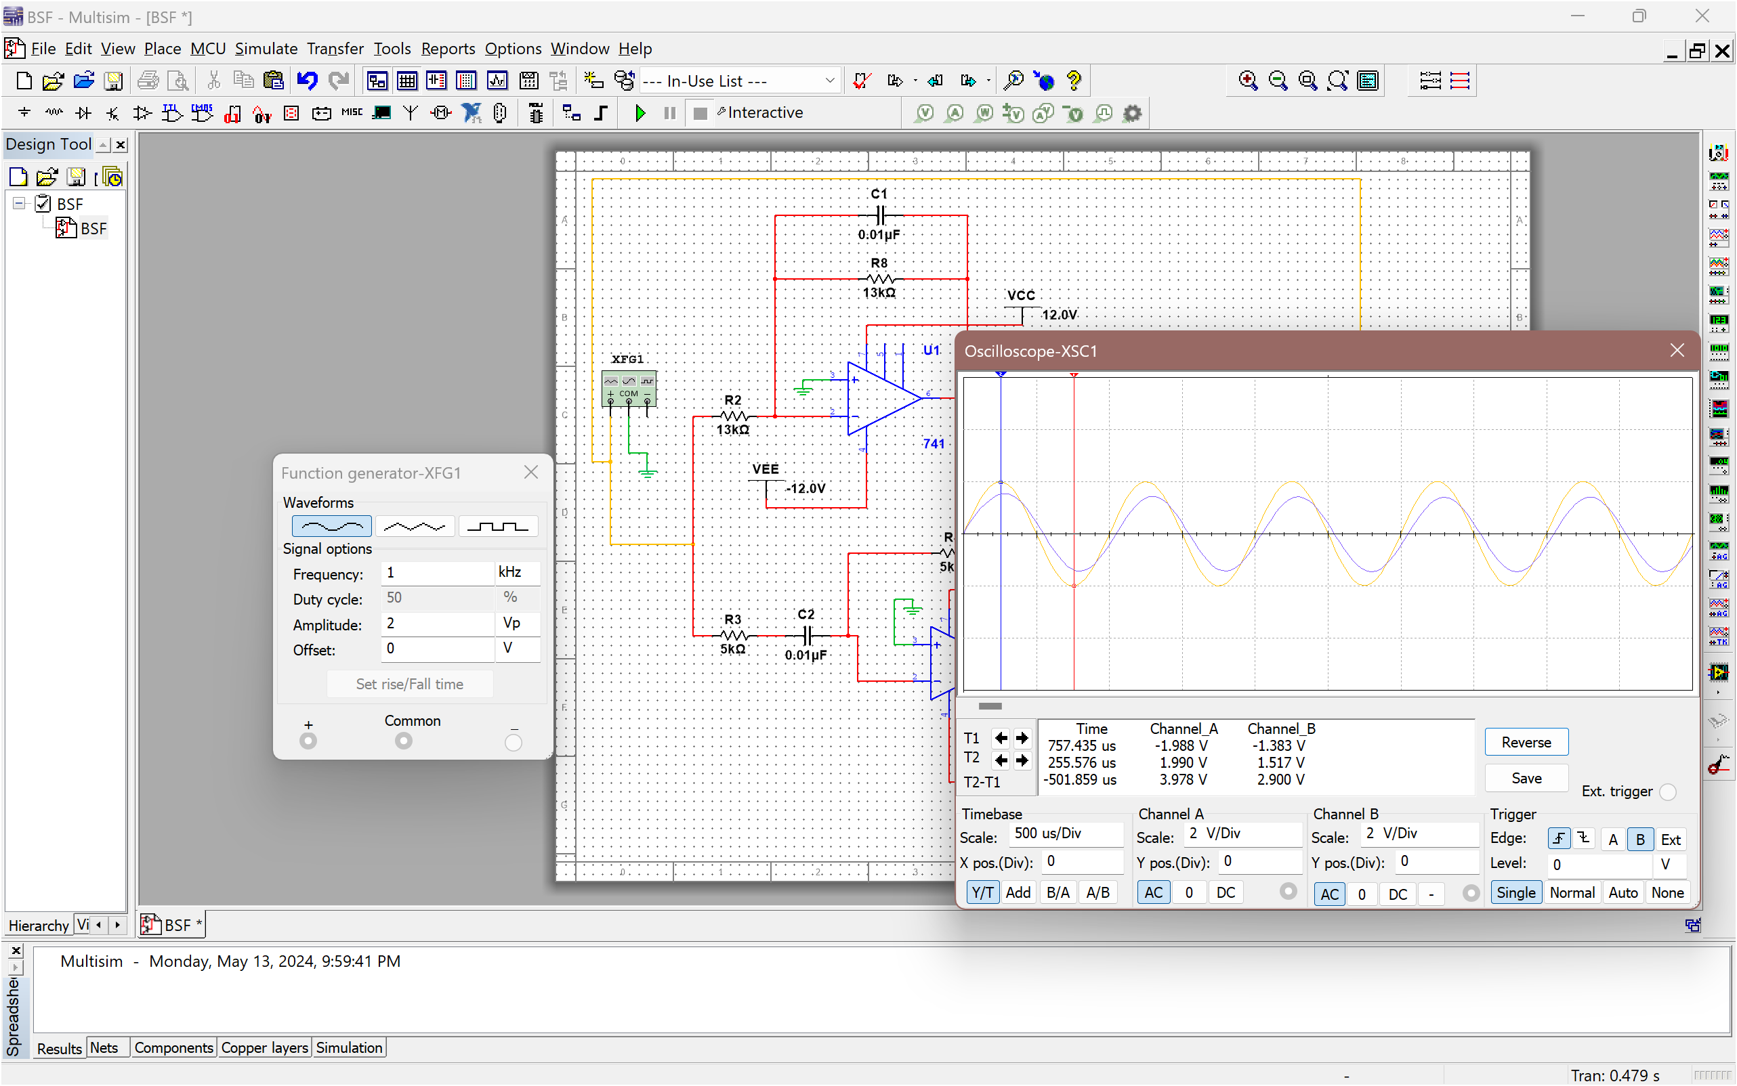

* 1. AFTER 1 Khz (2.23 KHZ, 3 khz)

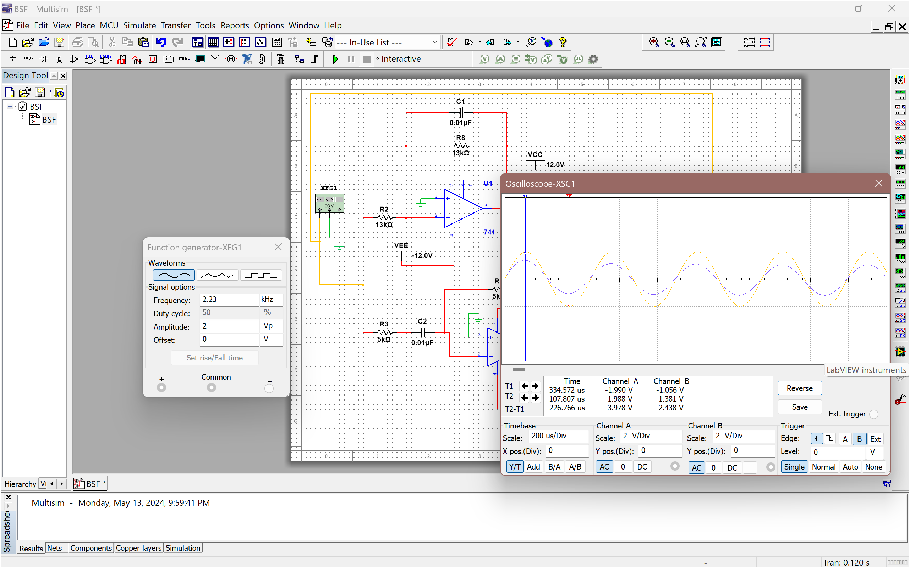

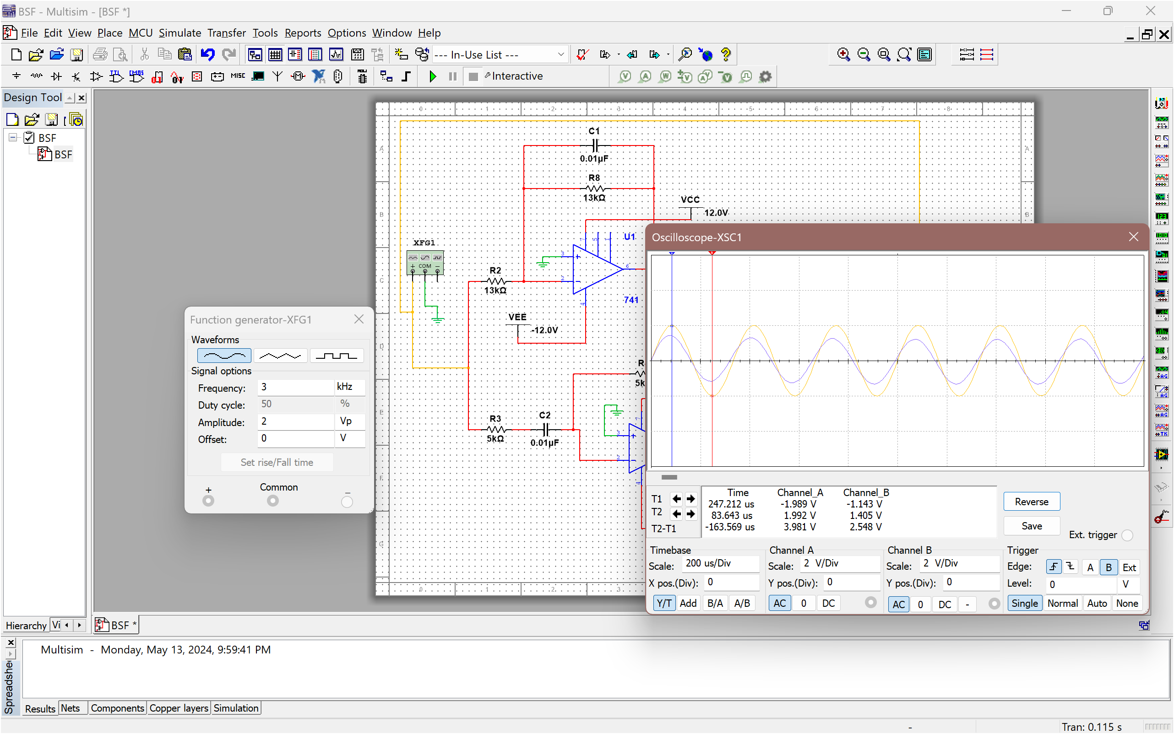

* 1. At 5 khz

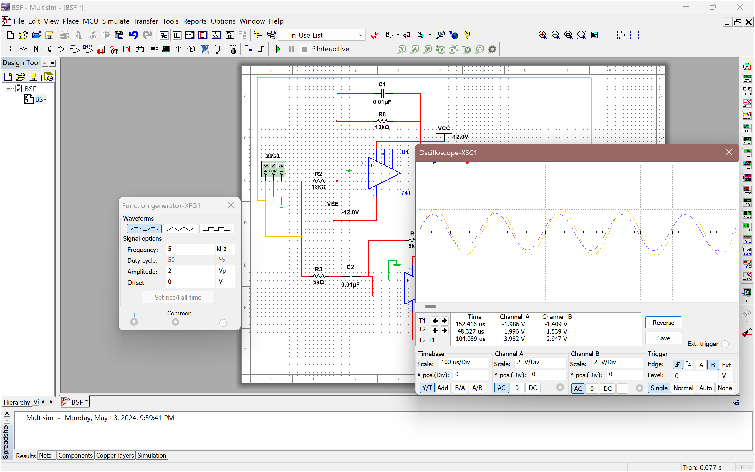

* 1. More THAN 5 khz (7 khz, 13 khz)

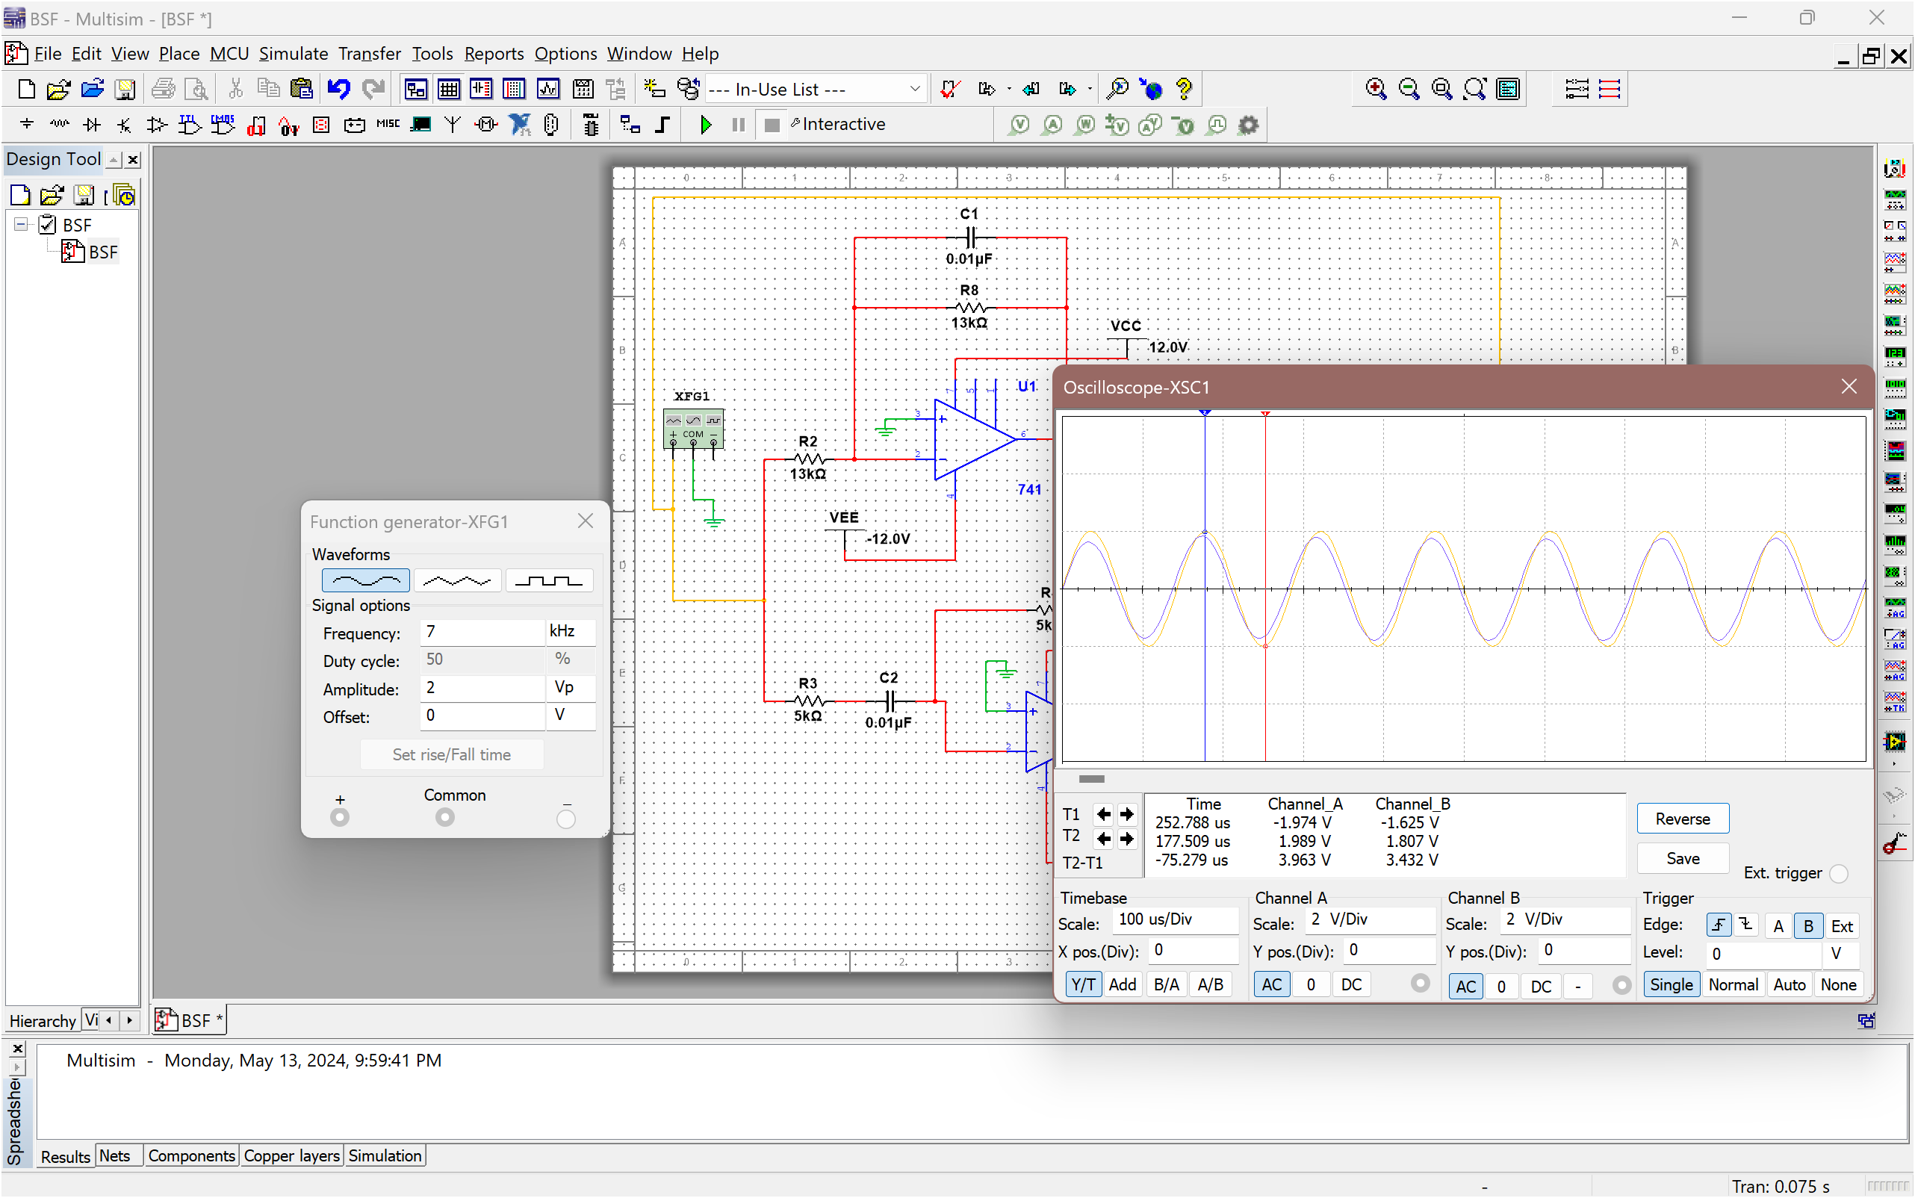

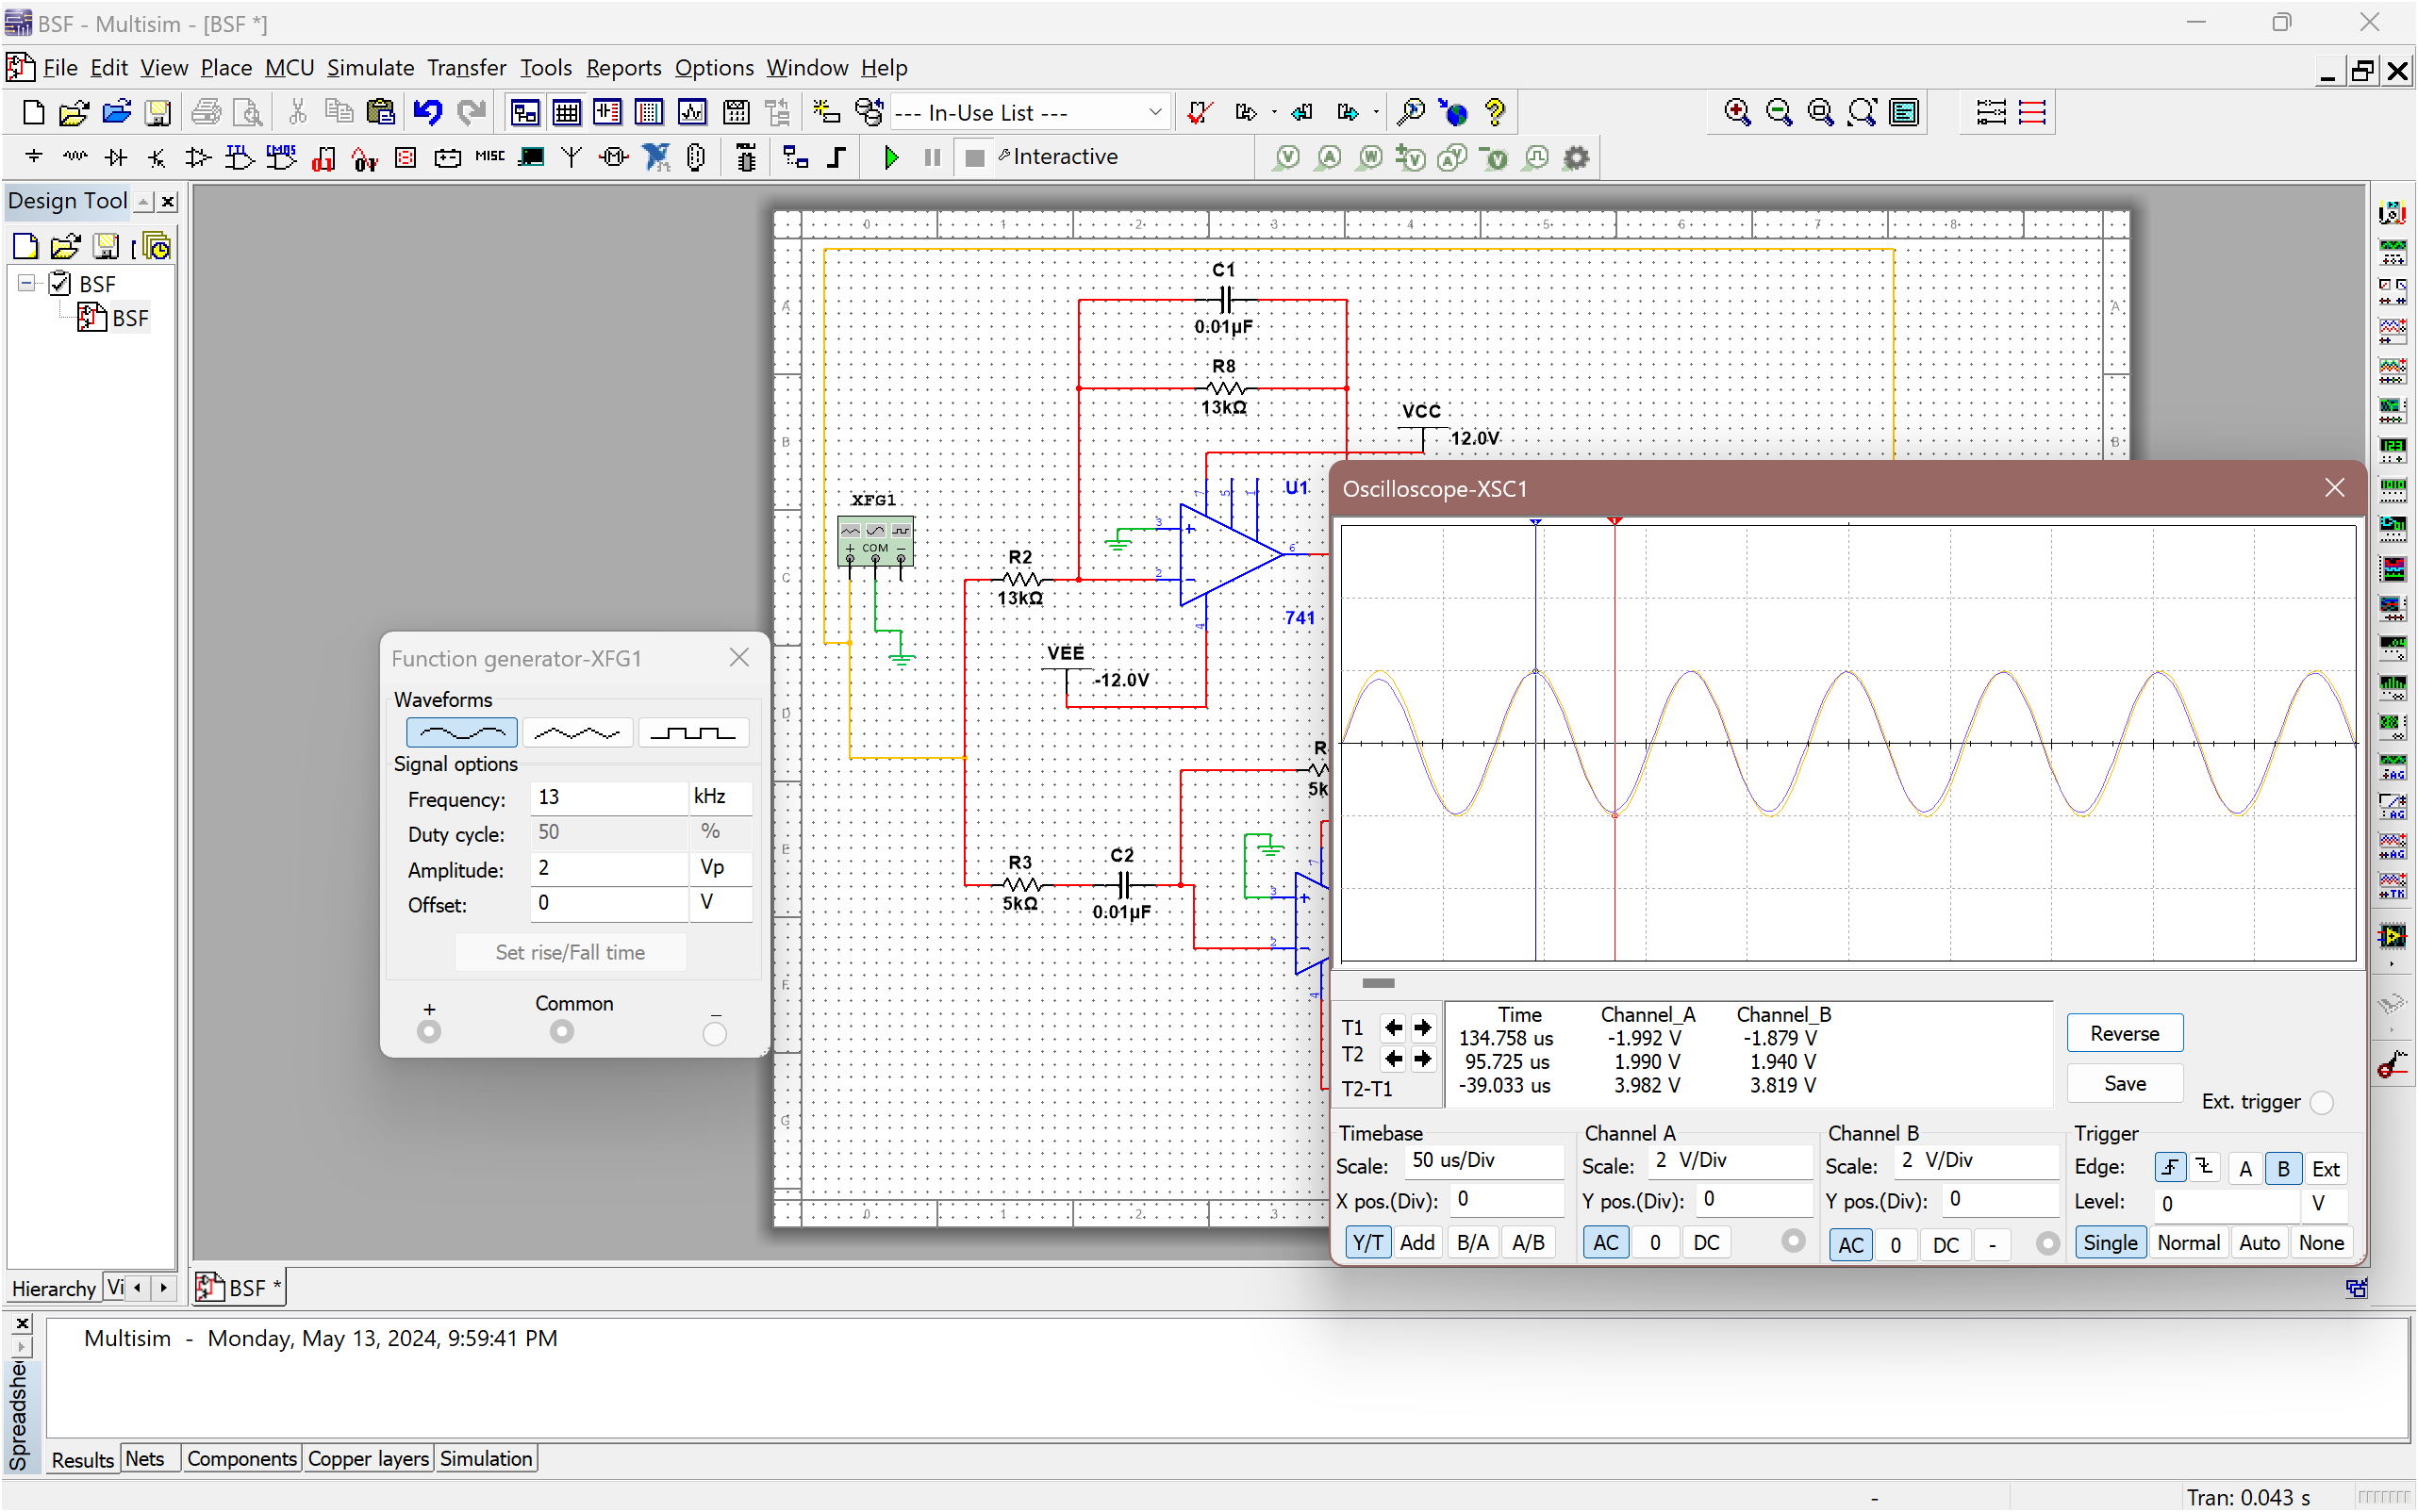

**Simulation GRAPH:**

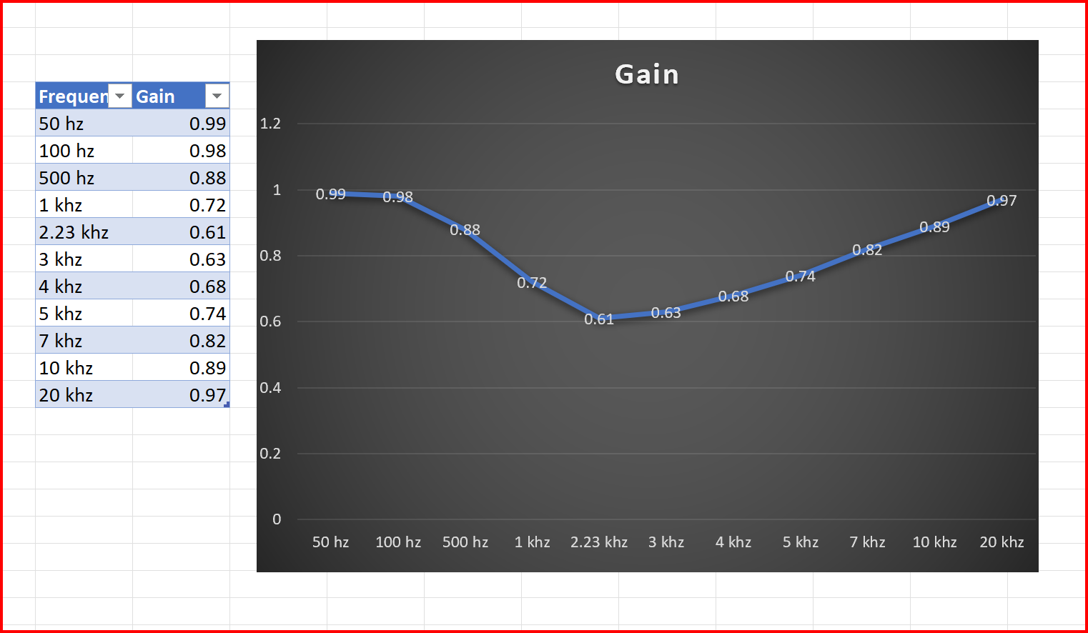

**HARDWARE VALUE GRAPH:**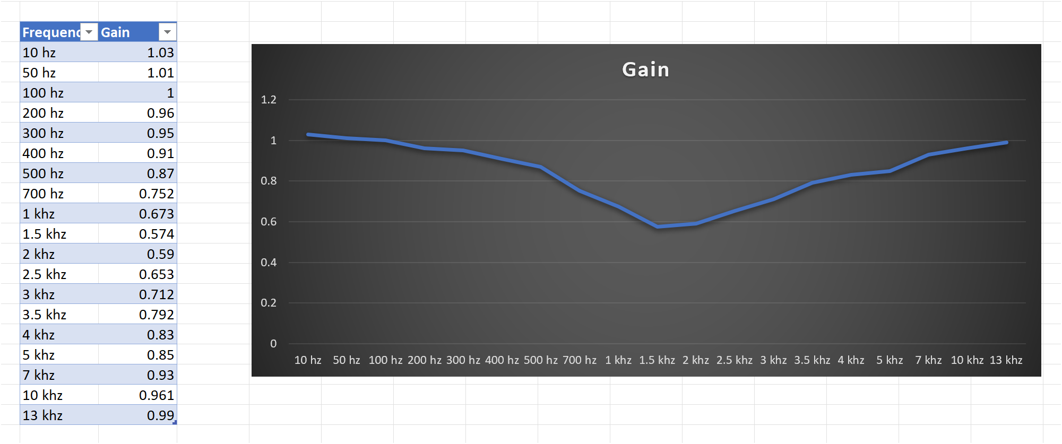

## HARDWARE RESULT

1. Before 1KHz

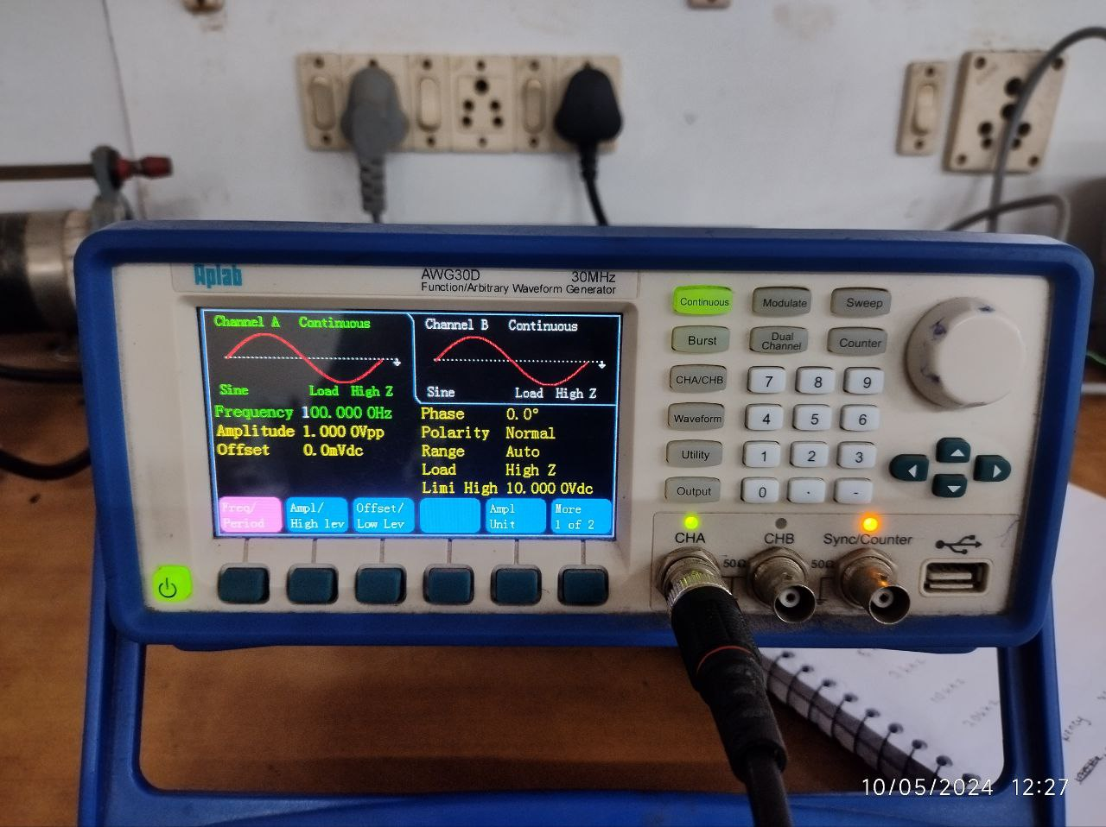

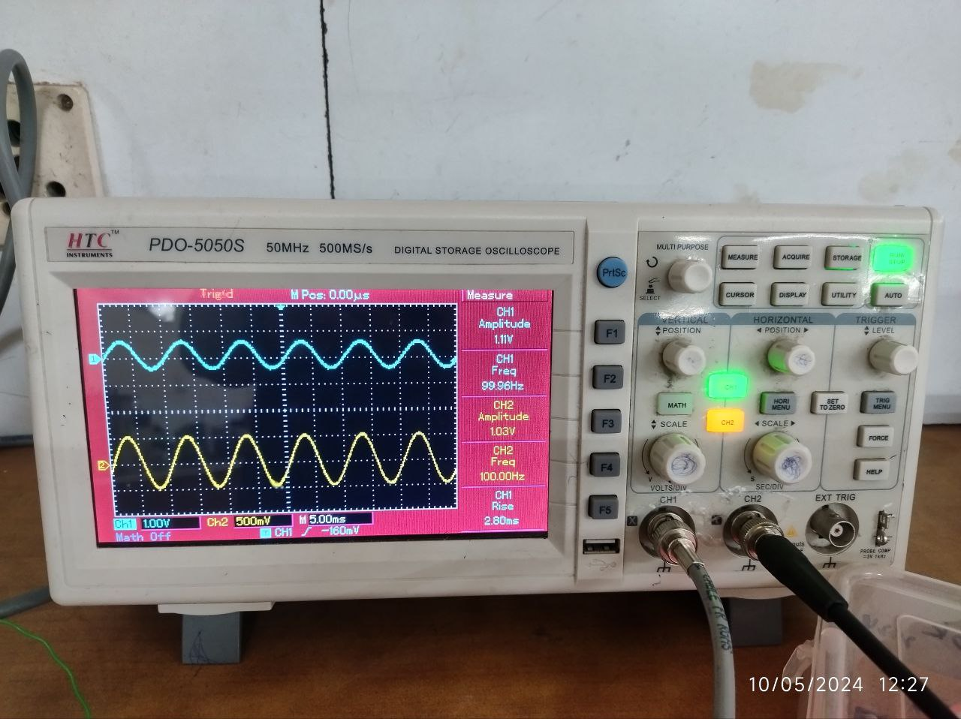

1. At1KHz

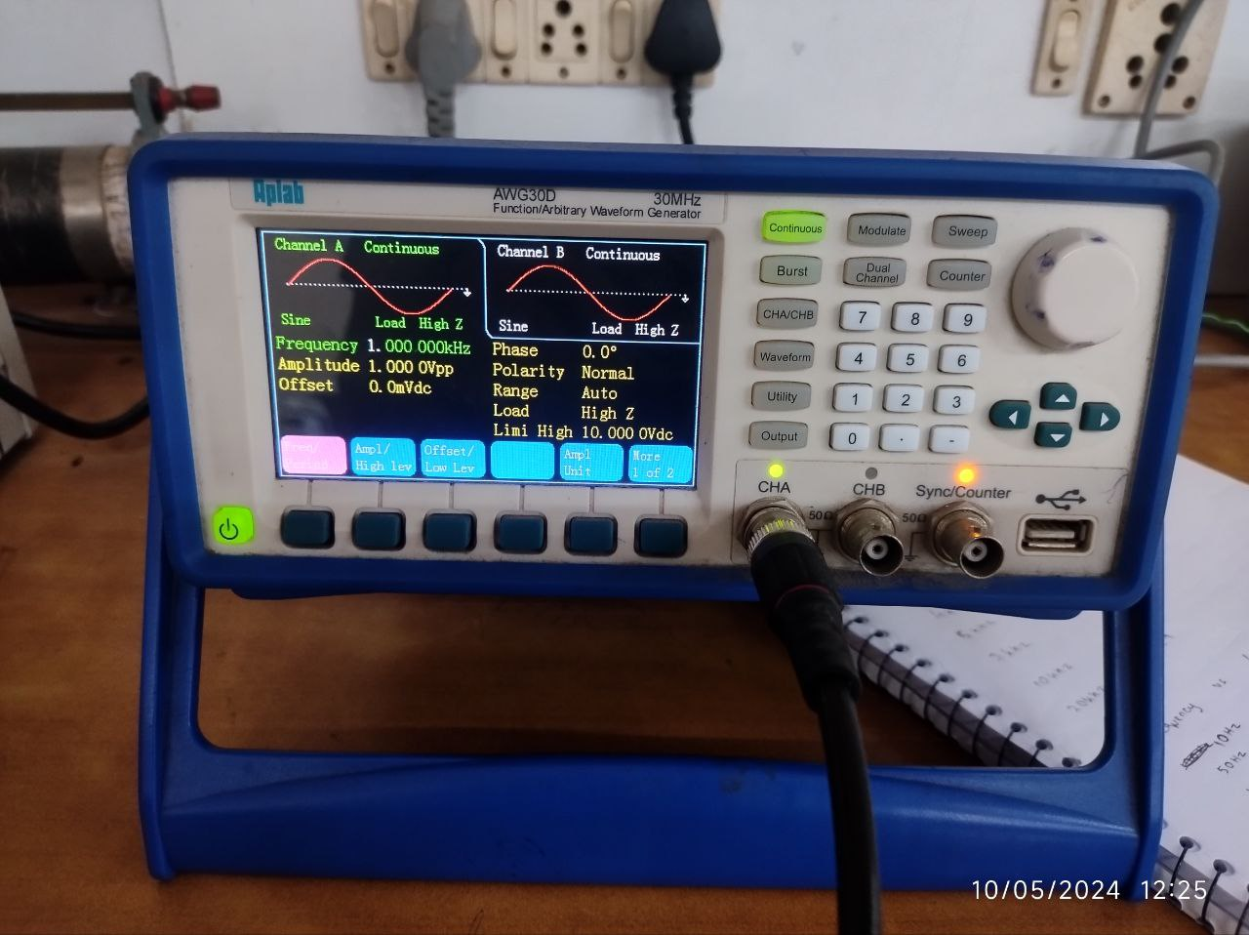

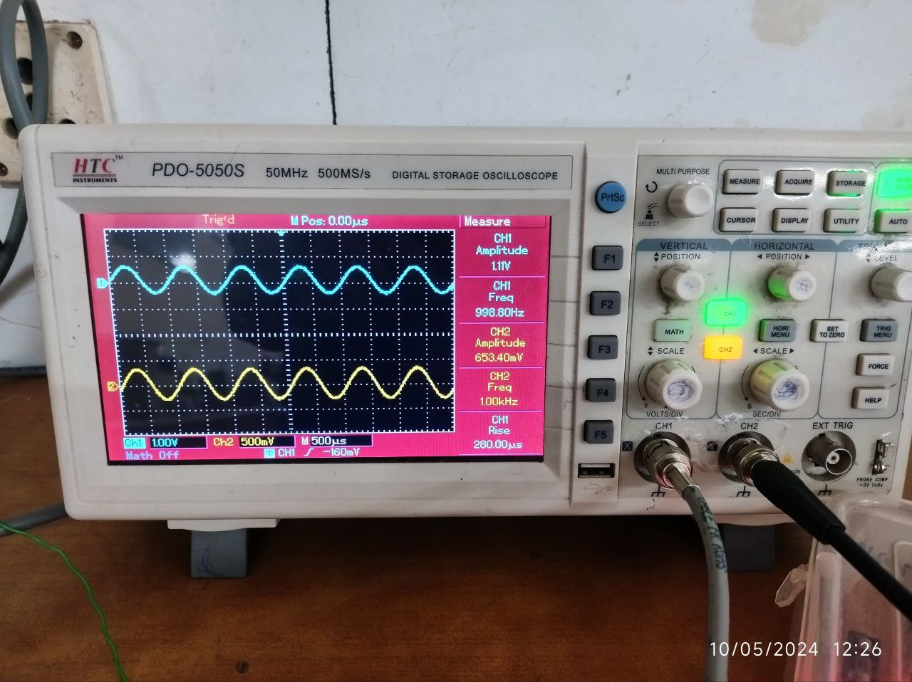

1. After 1 khz





1. AT 5 KHZ

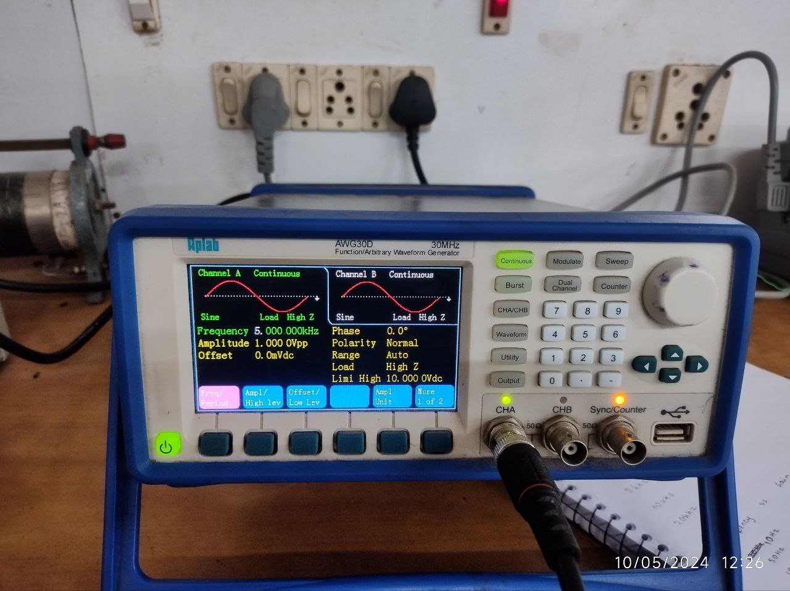

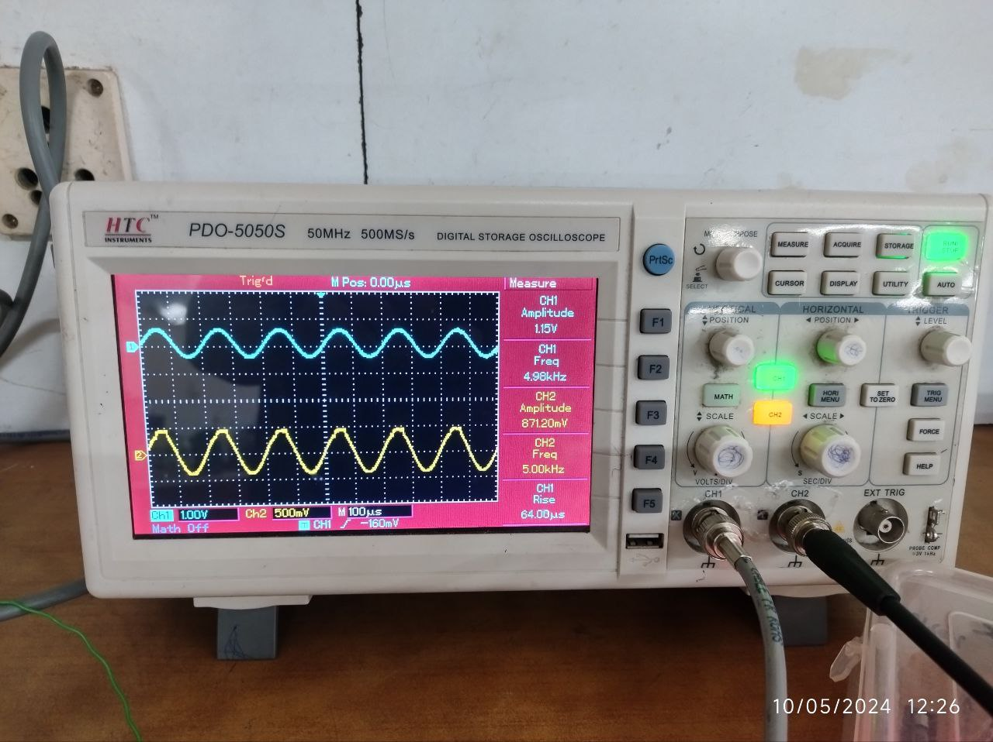

1. AFTER 5 khz

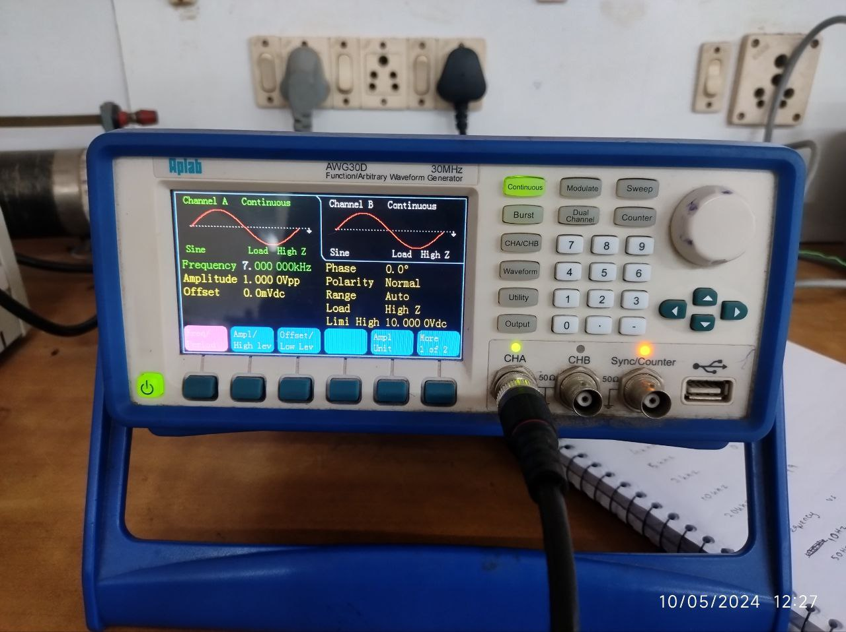

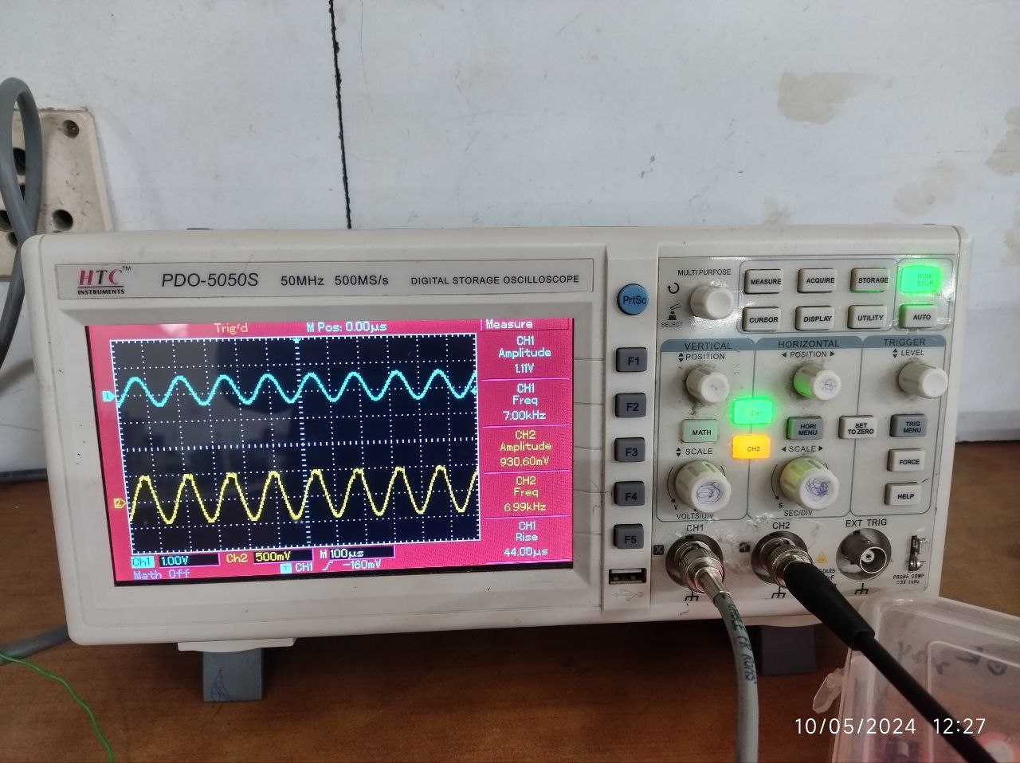

# COMMENTS

In conclusion, it has been successfully designed to block signals within the frequency range of 1KHz to 5KHz using a 2nd order active Band Stop Filter (BSF). The main goal of this project was to create a filter capable of attenuating signals within a certain frequency range while allowing all other frequencies to pass without any alteration.

An active filter design was used to do this since it can offer high gain and fine frequency control. The steeper roll-off characteristics of the 2nd order filter design improved the filter's ability to attenuate the desired frequency range.

In order to reach the intended cut-off frequencies, the design procedure involved choosing the right operational amplifier (op-amp) circuits and figuring out component values. To confirm the filter's effectiveness in blocking frequencies between 1KHz and 5KHz while keeping appropriate passband and stopband characteristics, numerous calculations and simulations were performed. low through with little to no change.

After successful modelling and verification, a hardware prototype was used to create and test the planned 2nd order active BSF. The outcomes showed that the filter successfully reduced signals within the designated frequency range to an acceptable level by suppressing them.

The successful conclusion of this study makes a contribution to the field of signal processing by offering an effective technique for attenuating undesirable noises within a particular frequency band. When the elimination of particular frequency components is necessary, the developed 2nd order active BSF can be used in a variety of industries, including as audio processing, telecommunications, and instrumentation. As a whole, this effort adds to the development of signal processing techniques and lays the groundwork for future advancements in active filter design.

# REFERENCE

* Fundamentals of Electric Circuits 5th Edition by Charles K. Alexander and Matthew N. O. Sadiku
* The Organic Chemistry Tutor YT <https://www.youtube.com/watch?v=ynIx3vNvdIM>
* Website <https://www.electronicshub.org/band-stop-filter/>

# DATA SHEET

